FlipBot: Small Robot Development Platform

Design Report for EGR102 Honors Enrichment Contract

April 13, 2021

Lukas Severinghaus

## Introduction:

This project was completed for an Honors Enrichment Contract in EGR102, Foundations of Engineering Design Project II, at Arizona State University. The goal of this project was to develop a small two wheeled robot for use as a low-cost development platform in inspection applications. Rather than assembling a collection of modules, this project focused on whole system integrated development, furthering my personal interest in exploring the steps behind developing a robot system from the ground up. This honors enrichment contract was run in conjunction with a second honors enrichment contract in EGR216, under the guidance of Dr. Ayan Mallik, to develop the power management component of the robot. Ultimately, this project is still ongoing, and has been, and will be, a valuable learning experience for my personal development as an engineer. This report examines the project through the steps of the engineering design process: Empathize, Define, Ideate, Prototype, and Test.

## Empathize:

The idea from this project came from when I toured a US Army Robotics R&D lab several years ago. I saw a robot that was designed to be tossed through a window and teleoperated so that soldiers could clear a building without ever having to step foot inside. A bit more research yielded the company behind this robot, Recon Robotics, and the robot itself, the Throwbot® 2, see Figure 1 below.

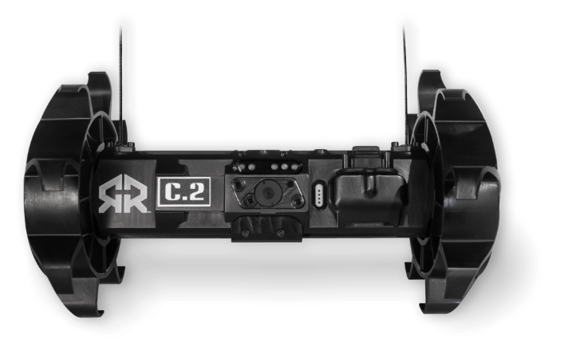

Figure 1. Recon Robotics Throwbot® 2 [1].

This robot retails for over $15,000, according to the GSA [2]. I was interested in learning about the development process behind a robot of this size, so I set out a few goals, and decided to build my own. In the end, I established three project criteria:

* **Small size.** This would allow me to use smaller components and try out surface mount components for the circuit boards.
* **Drive regardless of orientation.** If the robot flipped upside down, I wanted it to be able to reverse the controls so that the operator could continue to drive.
* **Wireless remote control.** I wanted the robot to be fully self-contained so it could run with only itself and the controller.

## Define:

Once I obtained approval for the project, the first step was to develop a block diagram. This helped define each part of the project and divided it up into small, manageable chunks. Figure 2, below, shows the block diagram for the electrical systems, where I focused most of my efforts.

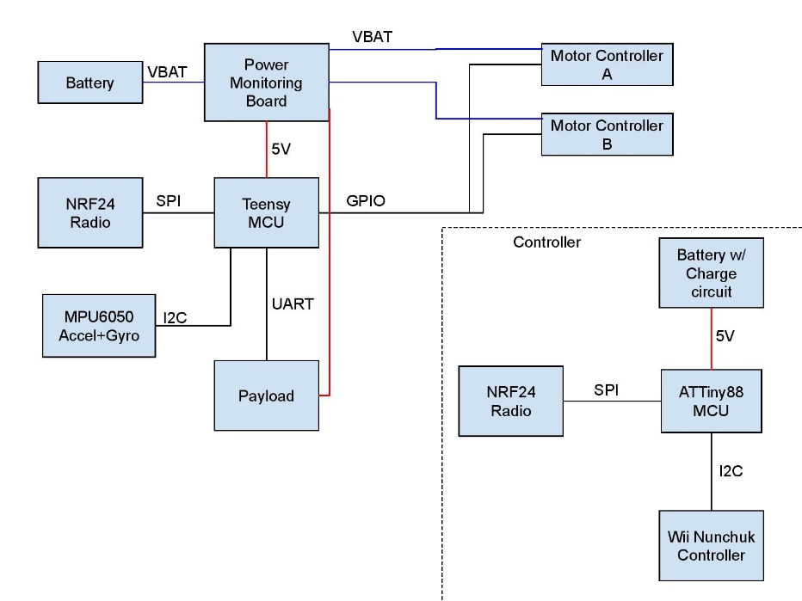

Figure 2. Electrical block diagram.

## Ideate:

As I finished the block diagram, I began researching each part and examining how I could implement it. I settled on a mixture of proven parts, that I had used before, and new methods, that I had not yet used. For example, I selected a Wii Nunchuk for the controller joystick, as I already had one on hand and it was more ergonomic than what I could design within the project timeframe.

For the mechanical design of the robot, I started mocking up what I wanted it to look like. The mechanical design had a large influence on the electrical design, as the printed circuit boards (PCBs) had to fit within the mechanical confines of robot. My initial CAD models were fairly crude, as I had little idea of how everything would go together, see Figure 3.

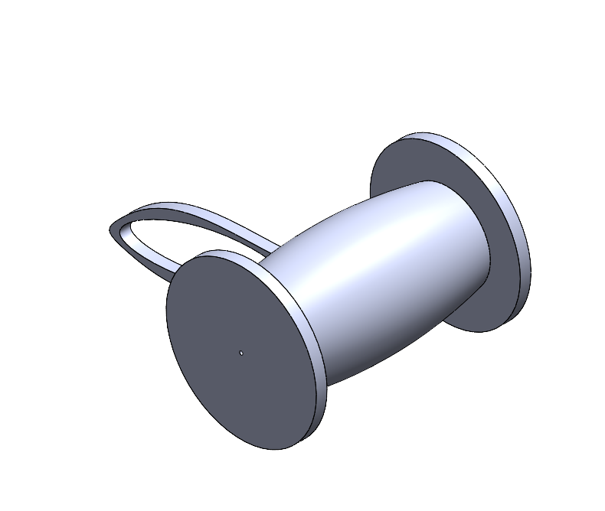

Figure 3. Initial CAD design with reversible tail for upside-down operation.

## Prototype:

Once I decided what parts I was going to use, I ordered a first batch of parts and assembled a breadboard prototype of the electrical system. The combined system was fairly complex and ended up covering five breadboards, but the testing helped eliminate most of the bugs in the initial designs. I used KiCAD, an open source EDA (Electronic Design Automation) program, to develop all the schematics and PCBs. These design files were then sent to the on campus PCB mill and assembled. The assembly process highlighted minor errors that had slipped past my initial breadboard testing, but ultimately no boards had to be re-milled. Figure 4 shows a render of the PCB for the wireless controller.

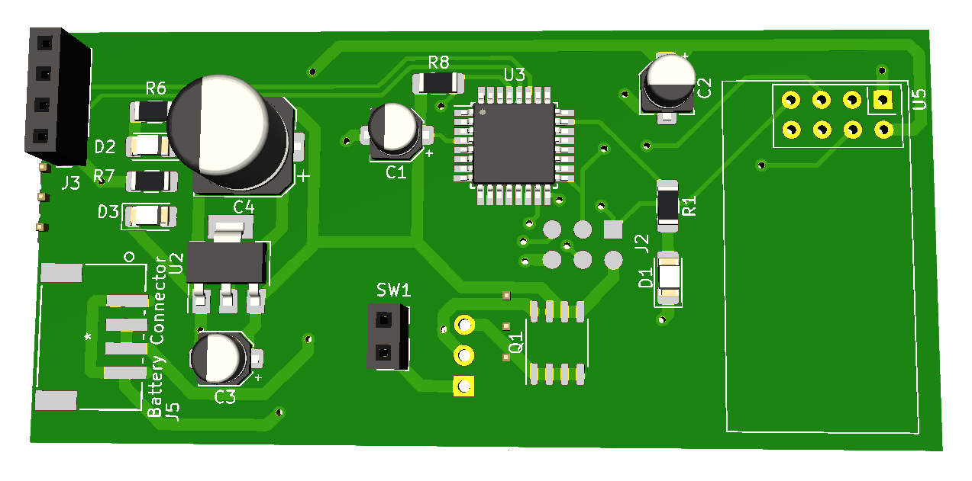

Figure 4. Controller PCB Render from KiCAD.

Additionally, as the PCBs reached their final forms, I used KiCAD to export STEP models of the boards into SolidWorks so I could model the mechanical design. Within the timeframe of the project, I was only able to build an initial prototype layout. While not as refined as I would have wanted, it allows easy access to all the components during testing, as shown in Figure 5.

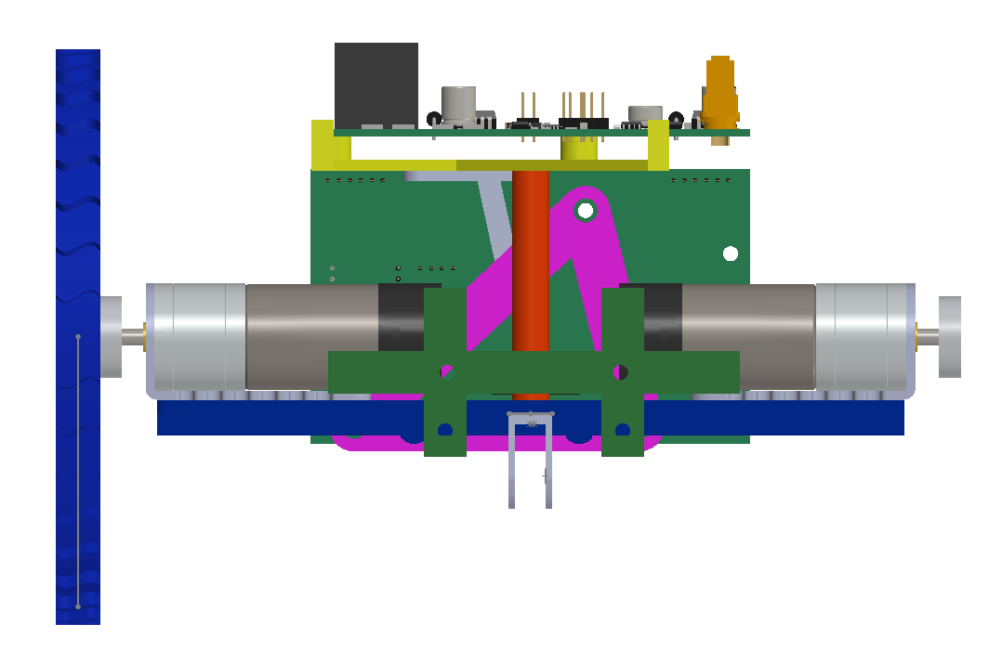

Figure 5. Prototype CAD assembly.

## Test:

The testing phase occupied at least half of the entire project timeline. The complexity of this project, combined with the new components I was using, made debugging a tedious, time consuming process. Ultimately, most of the bugs were ironed out, but one critical system failed to perform.

The controller’s design worked flawlessly, along with the wireless communications to the robot, and the orientation sensor, but the motor controllers, that provide power to the motors, had a fundamental design flaw. I had failed to properly breadboard test the level shifting hardware that enabled the microcontroller to communicate with the motor controllers and the parts were incompatible. By the time I came to this realization, it was too late in the semester to redesign the board, meaning the project would not be functional by the end of the semester.

## Conclusion:

Ultimately, the project was an invaluable education experience. I had the opportunity to dive into several areas I had not explored before, including:

* Multi-part 3D design and FDM printing
* Surface mount PCB design and design for integration
* Low level electrical design
* Software protocol design
* Integrated mechanical and electrical design

These are all skills that I plan to continue growing, and anticipate using, both in my education and in the workplace. Through this project, I gained an appreciation for the enormous amount of work that goes into developing a project like this. While the Honors Enrichment Contract is done, I plan to design a second revision of the electrical system to fix the issues present in the current version, with the hope that the project will be concluded in a functional state.

For more information on the project, visit: <https://github.com/kk6axq/flipbot>

## Acknowledgements:

The following sources were invaluable in the development of the project:

Dr. Ayan Mallik, for his assistance with the design of the power management board and for opening his lab for me to test the board.

dparson55, “dparson55/NRFLite,” *GitHub*. [Online]. Available: <https://github.com/dparson55/NRFLite>. [Accessed: 13-Apr-2021].

ElectronicCats, “ElectronicCats/mpu6050,” *GitHub*. [Online]. Available: <https://github.com/electroniccats/mpu6050>. [Accessed: 13-Apr-2021].

“Pololu - 34:1 Metal Gearmotor 25Dx67L mm MP 12V with 48 CPR Encoder,” *Pololu Robotics & Electronics*. [Online]. Available: <https://www.pololu.com/product/4864>. [Accessed: 13-Apr-2021].

## References:

[1] “THROWBOT® 2 ROBOT,” Recon Robotics. [Online]. Available: <https://reconrobotics.com/products/throwbot-2-robot/>. [Accessed: 13-Apr-2021].

[2] “Search Results,” U.S. General Services Administration. [Online]. Available: <https://www.gsaadvantage.gov/advantage/ws/search/advantage_search?q=0:2RECONROBOTICS&db=0&searchType=0>. [Accessed 13-Apr-2021].